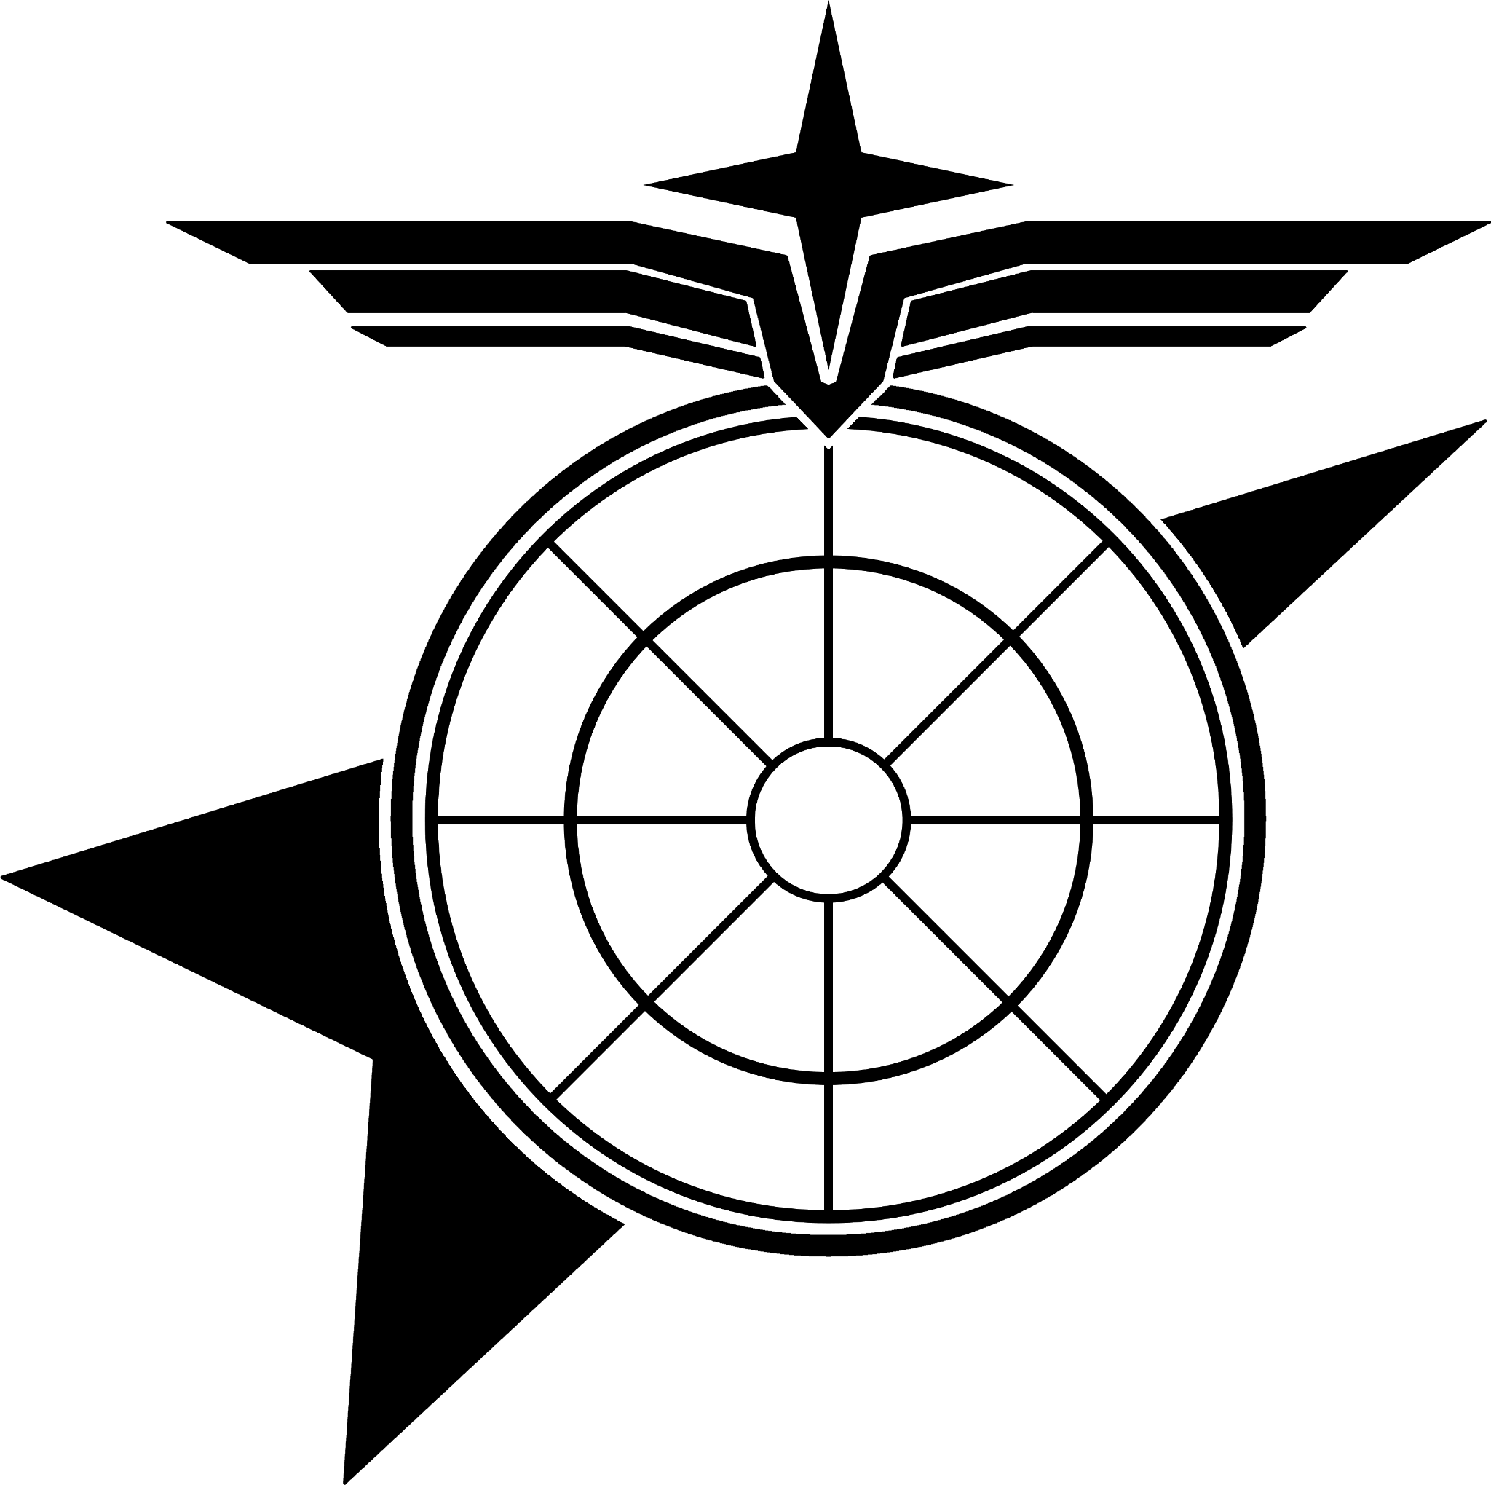

**UNITED NATIONS ARMED FORCES, OFFICE OF MILITARY RECORDS**

PERSONNEL DOSSIER COMPOSED BY MILITARY RESOURCES AND RECORDS DEPARTMENT

***RECORD SEALED, REFERENCE ADDENDUM 8919191***

| **I. PERSONAL INFORMATION** | |  |
| --- | --- | --- |
| **FULL NAME** | ORION T. BLACKBURN |
| **ALIAS/CALLSIGN** | N/A |
| **DATE OF BIRTH** | JANUARY 21, 2151 |
| **PLACE OF BIRTH** | AUBURN, KANSAS, UNITED STATES OF AMERICA, UNITED NATIONS |
| **GENDER** | MALE |
| **ETHNICITY** | CAUCASIAN |
| **NATIONALITY** | NATURALIZED CITIZEN |

| **II. PHYSICAL DESCRIPTION** | | | | | | |
| --- | --- | --- | --- | --- | --- | --- |
| **HEIGHT** |  | 5’11” | | **HAIR COLOR** | AUBURN | |
| **WEIGHT** |  | 179 lbs | | **EYE COLOR** | BROWN | |
| **BLOOD TYPE** | | A-POSITIVE (A+) | | | | |
| **DESCRIPTION:**  A thirty one year old male, possesses a semi fit body with a mesomorphic body frame. Occasionally possesses facial hair in the form of mustaches. Physical assessments and aptitude examinations have concluded their capability for field deployments.  Known to be left-handed. Typically he has short-auburn hair, but has been known to stylize or grow their hair out to ear-length hair. | | | | | | |

| **III. PSYCHOLOGICAL PROFILE** | |
| --- | --- |
| **MYERS–BRIGGS TYPING** | E N T P |
| **STRENGTHS & VIRTUES** | ADAPTIVE | ELABORATE |
| **WEAKNESSES & VICES** | IMPATIENT | PARANOID |
| **PHOBIAS & FEARS** | THALASSOPHOBIA | THANATOPHOBIA |
| **PERSONALITY:**  Orion is described as an energetic and analytical person. From his previous employment in the United Nations Army, he has learned to utilize his skills gained from the previous tours, to support the members of the UNAF. While several deployments and tours throughout the Mars Campaign and the Hyguera Campaign have scarred him mentally, they’ve served as applicable lessons to humble him. However, the deaths of peers and squadmates under his command as a result of his previous deployments in the UNAF have left him paranoid. Sometimes he appears impatient as a result of his experience.  Following his employment in the United Nations Army, he has only been given a further application to apply his skills to others. While generally supportive of his soldiers in his command, he is not hesitant to correct or otherwise put people in their place if necessary.  The roots of his expertise in influencing emotions, attitude and behavior of his targets stem from his service in the United Nation Army’s Civil Affairs. Some attributes of his work can be questionable but are notably inherited traits he acquired from his previous unit’s leadership. However, he attempts to ensure he keeps away from possessing a hostile leadership mentality as a way to preserve his unit and himself.  He has been diagnosed with Minor Post-Traumatic Stress Disorder as of May 21, 2180, by a registered civilian psychologist.  Moreover, his reported episode, where he allegedly fled under fire, raises further concerns. While Orion has shown resilience in his capacity to influence the attitudes and emotions of those around him, there is a fine line between maintaining authority and fostering a hostile environment. Blackburn is to be monitored closely for any sign of deviation from UNMC principles, as the lingering impact of these events may compromise both his leadership and the morale of those under his command. | |

| **IV. MISCELLANEOUS INFORMATION** | |
| --- | --- |
| **CRIMINAL RECORD** | ONE (1) CLASS-A MISDEMEANOR – UNDERAGE CONSUMPTION OF ALCOHOL |
| **MEDICAL HISTORY** NOT ON FILE | |

| **V. PERSONNEL DESIGNATION** | |  |
| --- | --- | --- |
| **PERSONNEL ID** | 947778844271433630 |
| **DEPARTMENT** | PUBLIC AFFAIRS |
| **RANKING** | MAJOR |
| **ROLE** |  |
| **CLEARANCE** | SECRET |

| **VI. OPERATING HISTORY** | |
| --- | --- |
| **OPERATING HISTORY** | |
| Born into a moderately wealthy family with a deep military lineage, was pressured from an early age to pursue a military career. He attended West Point Military Academy, where he graduated with marginal academic success. Following this, he completed Officer Candidate School and received a commission as a Second Lieutenant in the United Nations Army.  During the Mars Campaign against the Union of Progressive Peoples, Blackburn served as second-in-command aboard a planetary defense frigate. His commanding officer formally deemed him "severely incompetent." Blackburn was court-martialed after the Mars conflict but avoided a dishonorable discharge after being found only partially guilty. The charges were reduced, resulting in a demotion to First Lieutenant without a formal court appearance.  Following his demotion, Blackburn was reassigned to a logistics vessel supplying munitions and provisions for the ongoing war effort. Afterward, he transferred to the United Nations Marine Corps, taking command of an engineering unit on the fringes of UN territory. During a combat engagement with Colonial Liberation Front forces, Blackburn reportedly had a "mental breakdown," abandoning his unit. This report however, was never verified nor acted upon.  Over the next three years, Blackburn rotated through various postings and shipboard assignments. He was appointed Commanding Officer of the UNS Almayer as of July 12th, 2182. | |